Order Spirochaetales
Classification:

Order Spirochaetales includes two families, are Spirochaetaceae and Leptospiracea.
- Family Spirochaetaceae includes two pathogenic genera, are genus Treponema and genus Borrelia.
- Family Leptospiracea includes one pathogenic genus, is genus Leptospira.

General characteristic of Spirochaetes:
صفات عامة للـ Spirochaetes
- Spiral, long and thin cells.
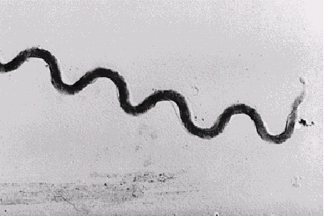
ولذا سميت Spirochaetesالتى تعنى coiled hair
- Shape and number of the coils vary from genus to another
Coils of Treponema; 6-14 short regular coils with tapered ends.
نلاحظ هنا أن اللفات على مسافات متساوية (Regular)
Coils of Borrelia; 4-8 wide irregular coils.
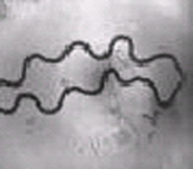 نلاحظ هنا أن اللفات ليست على مسافات متساوية (Irregular)
Coils of Leptospira; Many fine tightly coils with hooks at one or both ends.
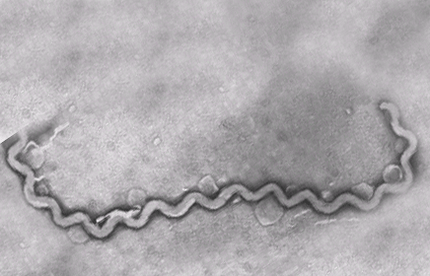
- Gram-negative bacteria but takes the stain poorly, only Borrelia can be easily stained by Gram stain, so they are stained by special stains in for demonstration as silver impregnation, Fontana stain, and Giemsa stain.
الصور الثلاثة السابقة بالـ silver impregnation
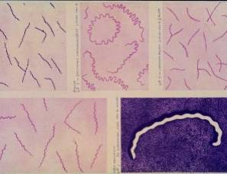 Borrelia by Gimsa stain
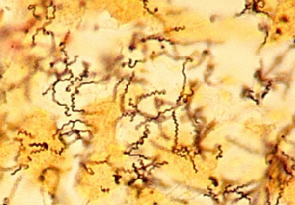

Borrelia by Fontana stain (brown long thin spiral cells with wide irregular coils against yellowish background)
- They are demonstrated effectively by using darkfield microscope and fluorescent microscope.
- 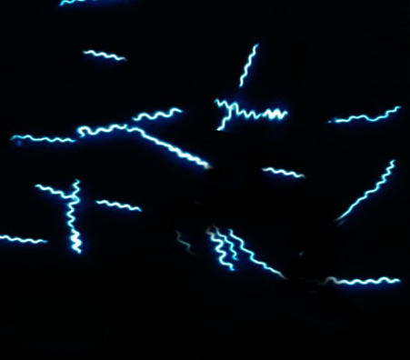 Borrelia by darkfield microscope
- They are motile by periplasmic flagella (endoflagella).
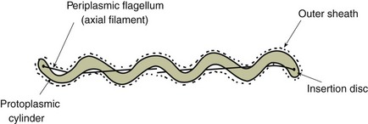

Number of endoflagella differs according to genus and species.
Also, motility differs from genus to genus
Motility of Treponema; rotating and undulating.
Motility of Borrelia; corkscrew like movement.
Motility of Leptospira; highly motile (Fast spiral rotation).
- Air requirement
Borrelia; microaerophilic.
Leptospira; Aerobic.
- Cultivation on artificial media
Treponema; can’t grow on artificial media while can be propagated in embryonated eggs or laboratory animals.
Borrelia; grow on complex liquid or semi-solid media containing N- acetylglucoseamine and long chain fatty acids, blood or tissue. Also, they can be propagated in embryonated eggs or laboratory animal.
Leptospira; grow on complex semi-solid media containing serum, vitamin B₁ and B₁₂. Also, they are propagated in embryonated eggs or laboratory animals.

Genus Treponema

Pathogenic Treponema species and diseases caused by them:-

- Treponema cuniculi causes Rabbit syphilis, Vent disease, Rabbit spirochaetosis or Treponematosis in rabbits.
Highly contagious disease characterized by presence of small nodules, ulcers or crusty scab- like lesions in the genital regions, nose, mouth, lips, chin and eyes. It is venereal and zoonotic disease.
- Treponema pallidum causes syphilis in human (مرض الزهرى). It is venereal disease. غير موجود فى مصر الا فى بعض الحالات القادمة من دول الخليج

Penicillin is the drug of choice for treatment of syphilis.

Genus Borrelia

Many of Borrelia species are non-pathogenic and commensals but some of them cause systemic infections.
They are transmitted to animals and human by arthropods (Tick and louse).

Borrelia species and diseases caused by them:-

- Borrelia anserine or Borrelia gallinarum causes avian borreliosis, avian spirochaetosis or fowl spirochaetosis in birds (chickens, turkey, pheasants, ducks, geese and wild birds).
It is characterized by fever, emaciation, cyanosis of the head, greenish diarrhea and hepatosplenomegaly with widespread haemorrhages (Mottled spleen).
Borrelia anserine is transmitted to the birds by soft ticks of genus Argus, through cannibalism parasitism and ingestion.
وجود القراد على الطيور وهذه الأعراض مشخص لهذا المرض
- Borrelia burgdorferi causes Lyme disease or borreliosis in dogs.

- Treatment of the infected cases by doxycycline and amoxicillin.

Genus Leptospira

Leptospira species are widely distributed in the nature particularly where the water found, so stagnant or slow moving water are predisposing factors for Leptospirosis.

Classification of Leptospira:

Through DNA homology, Leptospira is classified into two species are L. interrogans and L. biflexa.
- L. interrogans contains the pathogenic Leptospirae and on basis of serological reactions, currently there are 250 serovars within 23 serogroups.
- L. biflexa contains the saprophytic Leptospirae.

Common Leptospira serovars and diseases caused by them:
- L. interrogans serovar interrogans causes abortion and mastitis in cattle and sheep.
- L. interrogans serovar pomona causes Red water fever in calves & lambs and abortion in cattle, sheep, horses and pigs.
- L. interrogans serovar icterohaemorrhagiae causes fever, haemoglobinurea and abortion in cattle, sheep and goat.
- L. interrogans serovar canicola causes acute hepatitis with jaundice in dog (Canicola fever in dogs) and human (Weil’s disease).
- Many other serovars of Leptospira causes abortion and stillbirths in the domestic animals.

Treatment of Leptospirosis:

Penicillin will quickly stop leptospira from replicating but will not clear the carrier state.

Obligatory intracellular scotobacteria

Chlamydiae and Rickettsiae are gram negative bacteria but they are obligate intracellular parasites (resemble viruses in this character) therefore, they are grown in tissue culture, embrocated eggs or laboratory animals.
The obligate intracellular parasitism of Chlamydiae is due to that they can't synthesize ATP while that of Rickettsiae is due to that they are unable to produce sufficient ATP to replicate extracellularly and they require the rich cytoplasm to stabilize their unusually permeable cell membrane.

I- Order Chlamydiales

They multiply by a special developmental cycle include binary fission.
Morphology and culture characteristics:
- Gram negative bacteria but stained better with Giemsa or Macchiavello stain.
- Spherical small cells (0.5um).
- They are grown in tissue culture as HEP-2 cells, embryonated eggs (Yolk sacs of 6-8 day old) or laboratory animals as mice. This where they are obligate intracellular parasites.

Chlamydia species and their infections:
- Chlamydophila psittaci (formerly Chlamydia psittaci) causes Parrot disease, Parrot fever, Ornithosis, Avian chlamydiosis or Psittacosis in parrots, sparrows, gulls, pigeons, ducks, and hens.
This disease is characterized by affection of upper respiratory tract and yellowish green or grayish watery diarrhea with high level of urates.
In human, and Chlamydophila psittaci causes atypical pneumonia (Zoonotic disease).
- Chlamydophila psittaci is one of the major causes of abortion in sheep and cattle.

- Microscopical examination for film from samples stained with Giemse or Macchiavello stains Intracytoplasmic inclusions bodies "elementary and reticulate bodies".
Treatment of chlamydial infections:

Usually by doxycycline or tetracycline.

II- Order Richettsiales

Rickettsiae are maintained in the nature in certain arthropods as ticks, lice, and fleas and they are transmitted to human and animals by bite or faeces of the arthropod (arthropod borne infection) except Q fever which is transmitted by inhalation or ingestion.

Morphology and culture characteristics:
- They are short Gram negative bacilli, difficult to be stained by Gram but are best stained by Giemsa, Leishman or Macchiavello stain.
- They are grown in tissue culture, embryonated eggs or laboratory animals. This where they are obligate intracellular parasites.

Rickettsiae and their infections:
- Coxiella burnetii (C. burnetii) causes Q fever, Query fever, Queensland rickettsial fever or Abattoir fever in cattle, sheep and goats.
This disease is characterized by placentitis and abortion. C. burnetii affects human (Zoonotic occupational disease) causing influenza likes symptoms and hepatitis.
- Anaplasma marqinale causes Anaplasmosis in cattle and buffaloes.

Treatment of Rickettsial diseases:

Antibiotics used for treatment of Rickettsial diseases includes are doxycycline, tetracycline, chloramphenicol and ciprofloxacin.

